# Does Increasing landscape diversity in Farmed Closed Depressions (Potholes) increase profitability and ecosystem services?

### Progress Report & Renewal Request for Grant No. 2016-19

Date submitted: 1/13/2017

Proposal code number: E2016-19

Amount requested: $61,055 (Year 2)

### Investigators:

Amy Kaleita Andy VanLoocke

Associate Professor Assistant Professor

Agricultural & Biosystems Engineering Agronomy

Iowa State University Iowa State University

515-294-5167 515-294-8398

[kaleita@iastate.edu](mailto:kaleita@iastate.edu) [andyvanl@iastat.edu](mailto:andyvanl@iastat.edu)

Michelle Soupir Emily Heaton

Associate Professor Associate Professor

Agricultural & Biosystems Engineering Agronomy

Iowa State University Iowa State University

515-294-2307 515-294-1310

[msoupir@iastate.edu](mailto:msoupir@iastate.edu) [heaton@iastate.edu](mailto:heaton@iastate.edu)

# Scope of Work

The goal of this project is to stimulate farmer consideration of “retiring” farmed potholes into land cover that both improves water quality and saves money. We will do this by *measuring* key pothole and plant production metrics, *modeling* pothole hydrology, plant productivity and profitability under alternative management (farmed vs. perennial cover), and *informing* stakeholders with outreach partners. Specifically we will: i) instrument several farmed and artificially drained potholes *and* *measure* the frequency, duration and extent of ponding in the instrumented depressions as well as the water quality during times of ponding; ii) assess long-term pothole hydrological behavior (with a small-scale watershed *model*); associated crop growth, yields and environmental impacts of farming potholes in standard corn/soybean rotation compared to incorporating perennials into them (with ecosystem *model*); and profitability (with sub-field, state-wide profitability *model*); iii) then *inform* stakeholders of findings through collaborative outreach with high-impact partners.

Instrumentation and data collection for the 2016 season was completed at seven potholes, six of which are in conventionally farmed fields, and the seventh is in the Conservation Reserve Program and merges into Miscanthus test plots. Primary data collection was: depth of ponded water versus time (hourly) for mid-May through late October; water quality samples on days with sufficient ponding to collect a sample; and periodic measurements of crop canopy (leaf area index) and biomass (destructive samples). These data are currently being used both to understand the behavior of these features with respect to hydrology, and to parameterize and assess the performance of hydrology and crop growth models. Stakeholder outreach is planned for the coming year.

# Project Summary

Below, we summarize the progress in each of our project objectives.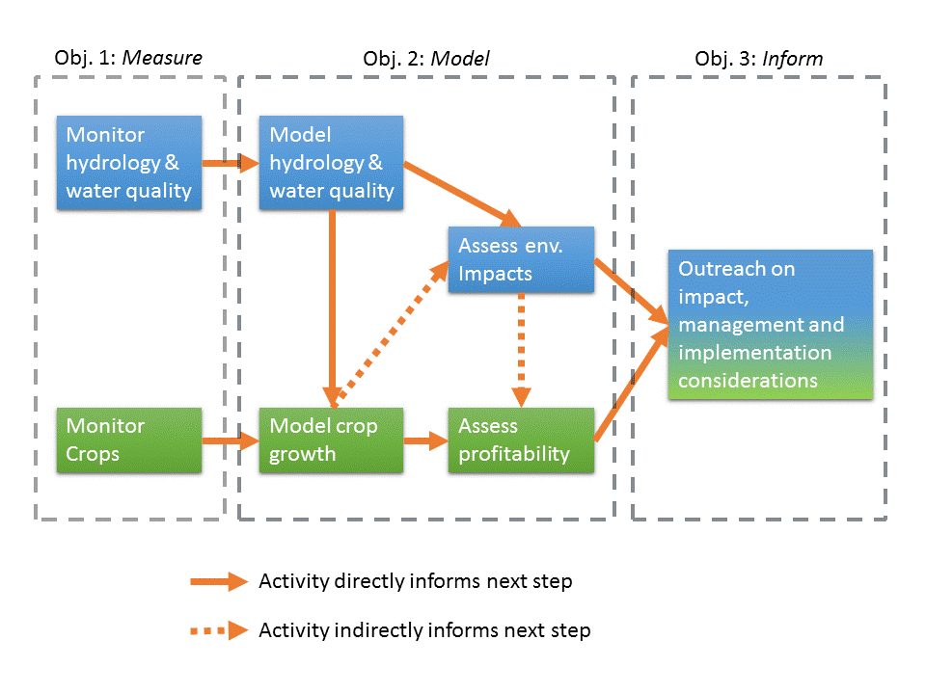

## Progress towards project objectives

**Objective 1: *Measure hydrology of potholes, and crop growth within potholes*. Evaluate the hydrologic and water quality trends of farmed pothole wetlands under conventional (corn/soybeans) and alternative (CRP and *M. × giganteus*) management. Monitor *M. × giganteus* growth in a pothole compared to upland areas.**

In 2016 (year 1 of this project) we installed pressure transducers with dataloggers at the “bottom” of seven pothole depressions near Ames, Iowa. Six of these potholes were in fields with corn/soybean management, though the drainage area for one of the potholes also included switchgrass plots. The seventh pothole is in a small section of CRP, and bleeds into Miscanthus plots, which comprise the majority of its drainage area. This will resume in 2017 (year 2 of this project). The pressure transducer data allowed us to measure the depth of ponded water above the bottom of each pothole, on an hourly basis. By combining the ponded depth timeseries with an assessment of the local terrain we also generated a timeseries of ponded water volume and spatial extent of flooding. Furthermore, we also monitored crop status at these sites by making periodic measurements of leaf area index (LAI).

Year one of the hydrology and water quality monitoring was wrapped up in late October 2016. Especially in the latter half of the season, there were frequent rainfall events so that our dataset is fairly robust, including prolonged inundation in several of the potholes. Water quality samples were collected but to date are only partially analyzed (we are awaiting results from the ISU ABE Water Quality Lab).

One challenge was in collecting representative samples during low-depth ponded conditions. When the ponded depth of water is very shallow, it’s difficult to collect samples that are not full of sediment due to stir-up and suspension. We are in the process of determining if we should implement a minimum depth for WQ sampling.

Making observations of LAI and biomass was relatively straightforward, and no unforeseen challenges were encountered.

One overarching challenge of our field sites is that detailed topographic data analysis indicated that the pothole with Miscanthus is a much less distinct feature than the other potholes. This may complicate our ability to draw conclusions from the Miscanthus behavior. We are considering adding soil moisture monitoring in the Miscanthus section of that pothole as an additional data stream for 2017.

An unexpected wrinkle is that the Bakken pipeline route is slated to bisect the Been field. Fortunately, after reviewing the plans and the related 150-ft wide easement for the pipeline, we believe the effects on our monitoring will be minimal; the route is along a subwatershed divide and thus only touching the edges of some of the microwatersheds draining into our potholes. We considered other sites as well, which the ISU Research Farms superintendent helped us to brainstorm, but ultimately felt that the diversity, connectivity, and number of potholes available for study at Been, plus the benefit of much ancillary and prior data available for this field, made this the best site choice even with the disadvantages posed by the pipeline.

**Objective 2: *Model hydrology, crop development, and profitability in potholes*. Monitor and simulate the effects of ponded and saturated conditions in farmed potholes on crop growth under conventional and alternative management. Use data to refine sub-field, statewide profitability analysis.**

Building of hydrology model inputs and framework for 2 of the 7 potholes is complete, and we are in the process of determining a calibration procedure for verifying model performance. In Year 2, we will complete the hydrology model-building for all of the monitored potholes, and then run approximately 30 years of past weather data through the models to simulate the long-term inundation patterns, including stormwater storage, overflow, duration and spatial extent of flooding capable of limiting crop growth and yield. Modeling will be done for both the current scenario (corn-soybean rotation) and simulated ‘retirement’ scenarios of perennial cover, including the bioenergy and potentially flood tolerant crop *M. × giganteus*, in the pothole zone only.

Using the hydrology simulations we can drive a dynamic crop growth model on a sub-field level that simulates flood effects on crop development and ultimately yield under conventional and perennial management. In year 1, the Agro-IBIS model was parameterized for our study sites, and innovations were developed to allow the model to simulate perennial bioenergy plans, and to develop the model’s ability to simulate drown-out. The parameterization and model changes will continue to be refined in Year 2 using the observed data from 2016.

In year 2, a series of scenarios that quantified the impacts of current and projected future precipitation patterns were simulated using the calibrated model. The results indicated that in most 10-year windows the potholes under examination would lose most if not all corn and soybean for a significant portion of the pothole. This was evaluated against historical yield maps and largely confirmed our predictions. Next we conducted the same set of simulations with miscanthus in the potholes instead. Those results indicated that, based on current parameterization, miscanthus would suffer much smaller losses across climate scenarios. In the final stages of the project we are finalizing a framework to analyze the outputs from this in the context of profitability, clarifying the economic opportunity that exists from changing management of farmed potholes.

**Objective 3:  *Inform stakeholders about impacts of alternative management in farmed potholes.* Integrate findings into ongoing, collaborative outreach with high-impact project partners.**

In year 1, we described our pothole research at a joint field day with the University of Iowa, Iowa Learning Farms and the Eastern Iowa Airport, as well late-season flooding experience on the ISU Biomass Facebook page. In year 2 we will begin a more focused outreach effort. By leveraging partnerships with the University of Iowa Biomass Fuel Project, the Center for Rural Affairs, the Iowa Soybean association and an established network of ISU Extension staff, we will be able to share the findings of this research with a broad community of stakeholders interested in transitioning land management in farmed potholes.

Outreach in 2016 included presentation at joint field days (left) and social media sharing of pothole inundation with perennial and annual vegetation differences (right).

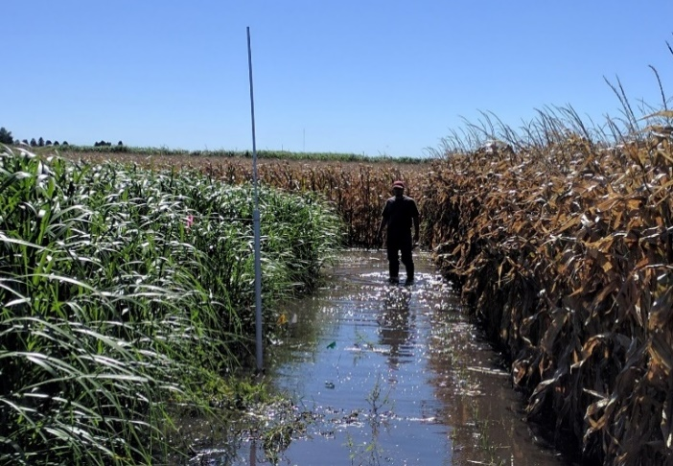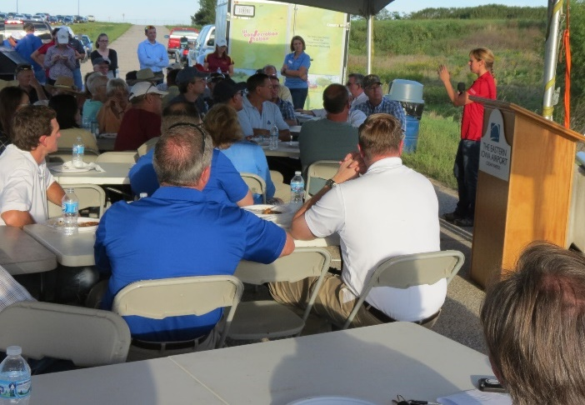

## Timeline

Shading indicates original timeline, X indicates the scheduled element is complete, P indicates the scheduled element is partially complete.

|  |  |  |  |  |  |  |  |  |  |
| --- | --- | --- | --- | --- | --- | --- | --- | --- | --- |
| Project Tasks | Jan-Mar 2016 | Apr – Jun 2016 | July-Sep 2016 | Oct-Dec 2016 | Jan-Mar 2017 | Apr – Jun 2017 | July-Sep 2017 | Oct-Dec 2017 | Jan-Mar 2017 |
| ***Objective 1: Evaluate the hydrologic and water quality impacts of farmed pothole wetlands.*** | | | | | | | | | |
| Monitor water depth and surface area of ponded storage, and quality of water in the potholes |  | X | X |  |  | X | X |  |  |
| Monitor miscanthus development in context of landscape position (pothole and not) |  | X | X |  |  | X | X |  |  |
| ***Objective 2:*** | | | | | | | | | |
| Simulate pothole inundation under current and alternative scenarios, including systems of connected potholes, under a range of historical weather-years |  | X | X | X |  |  | P | P |  |
| Initial crop model simulation preparations including incorporating soil data and linking AnnAgNPS water ponding depth outputs with AgroIBIS-VSF. |  | X | X | X |  |  |  |  |  |
| Crop model evaluation against historical yield data |  |  |  | X | X |  |  |  |  |
| Final crop model calibration and evaluation against data collected during this and concurrent projects |  |  |  |  | X | X | P |  |  |
| Perform sub-field level economic analysis to determine profitability of farmed potholes under a range of conditions and variety of scenarios |  |  |  |  |  | P | P | P |  |
| ***Objective 3: Inform stakeholders of findings through collaborative outreach with high-impact partners*** | | | | | | | | | |
| Field days, grower meetings, publication development and stakeholder engagement will occur throughout this project. | X | X | X | X | X | X | X | X |  |

# Technical SUmmary

## OBjective 1: Monitoring

Figure 1 below shows the locations of our monitored potholes in conventional management. These are located at ISU’s Been and S. Woodruff Farms just southwest of Ames. The seventh monitored pothole, in CRP at ISU’s Sorenson Research Farm, approximately 3.7 miles northwest of Been, is not shown.

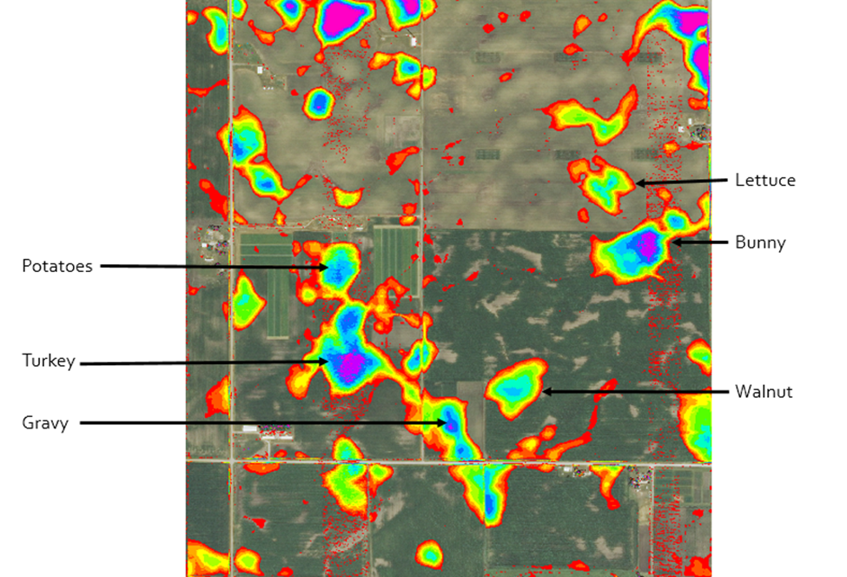

Figure 1. Arrangement and naming convention for six of the seven monitored potholes. Shading indicates depth of the pothole depressions. The seventh pothole, named “Mouth”, is located in a different field and is not shown here.

Water depth data is shown in Figure 2. Compared to our prior observations (2010 and 2011) at two of these potholes, the 2016 season had fewer early-season events and more late-season events. In particular, two events in late September causing the deepest and longest duration ponding. Nonetheless, the relatively small ponding event at Lettuce in the early season was significant enough to cause notable crop loss due to drowning. This can be seen in the leaf area index measurements shown in Figure 4.

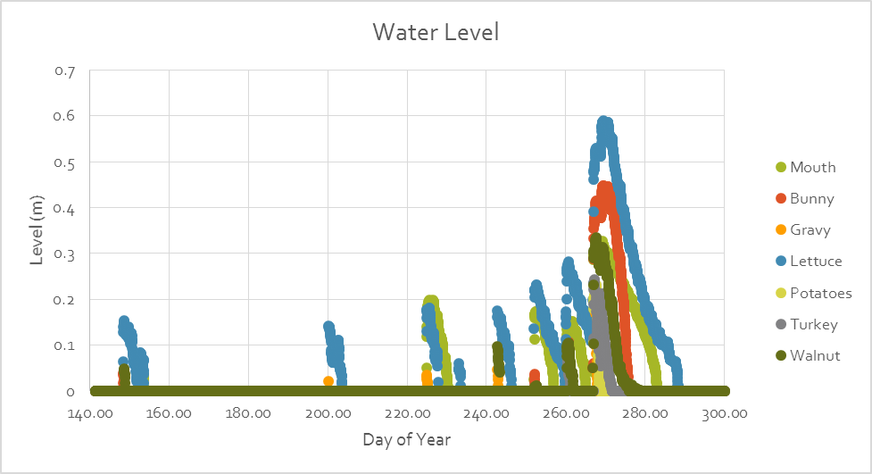

Figure 2. Time series of measured water depth in each of the seven potholes, from May 19, 2016 (DOY 140) to Oct. 26, 2016 (DOY 300).

Most ponding events were short-duration, lasting three days or less. Five of the six conventionally managed potholes experienced at least one ponding event lasting 5 or more days, with Lettuce experiencing one period of ponding that lasted for more than three weeks. The frequency and duration of ponding at each pothole is showing in Figure 3.

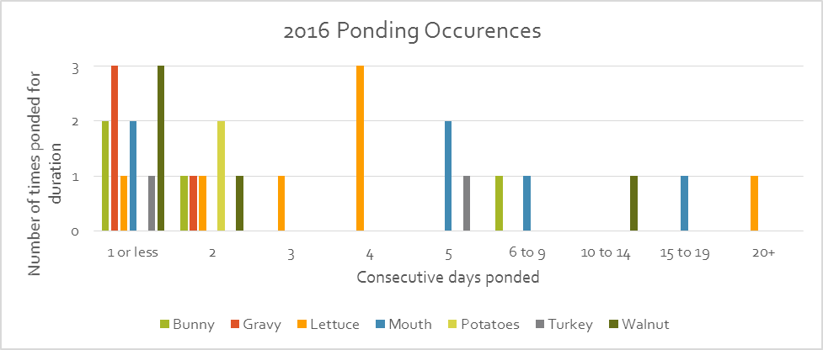

Figure 3. Frequency of ponded conditions by how long the ponded conditions lasted, for each of the seven monitored potholes.

An example of the LAI measurements is shown in Figure 4. Leaf area index is a measure of plant canopy (amount of leaf area as viewed from below, per unit area). Higher values indicate more leaf area. LAI values in the Lettuce pothole are substantially lower than in Bunny, illustrating the drown-out effect of early-season ponding at Lettuce.

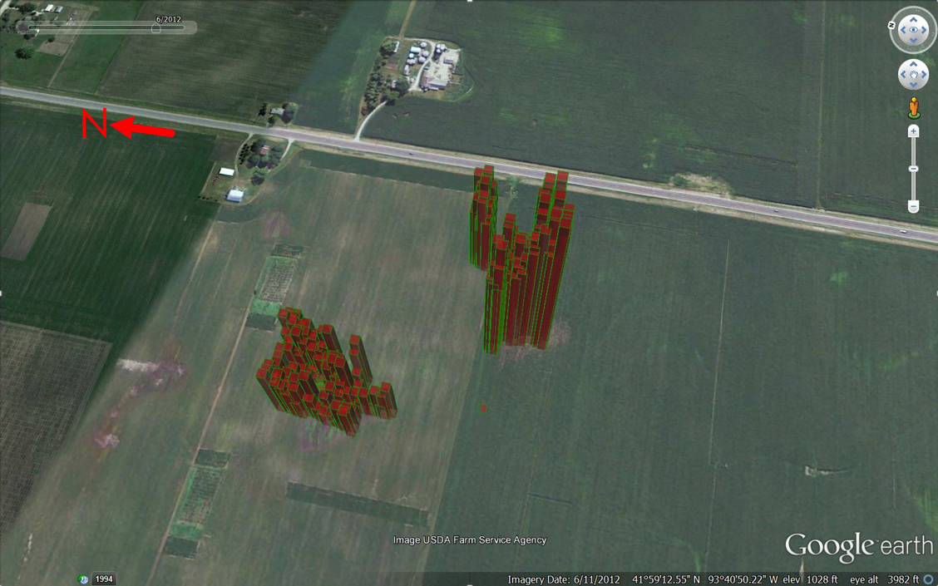

Figure 4. Leaf Area Index (LAI) measurements taken throughout Been potholes Lettuce (left) and Bunny (right), 8/16/2016. Taller bars correspond to larger values of LAI and thus to more robust leaf cover.

Effects of the ponding can also be seen in photos from our field visits to collect water samples in late September, shown in Figure 5. One clearly shows the sparsity of crop cover within Lettuce. The other shows a freshwater fairy shrimp, which were plentiful in Lettuce after several weeks of ponded conditions. These shrimp, adapted to “vernal pool” environments, lay eggs which dessicate and can remain viable even after several years, then hatch when conditions are favorable.

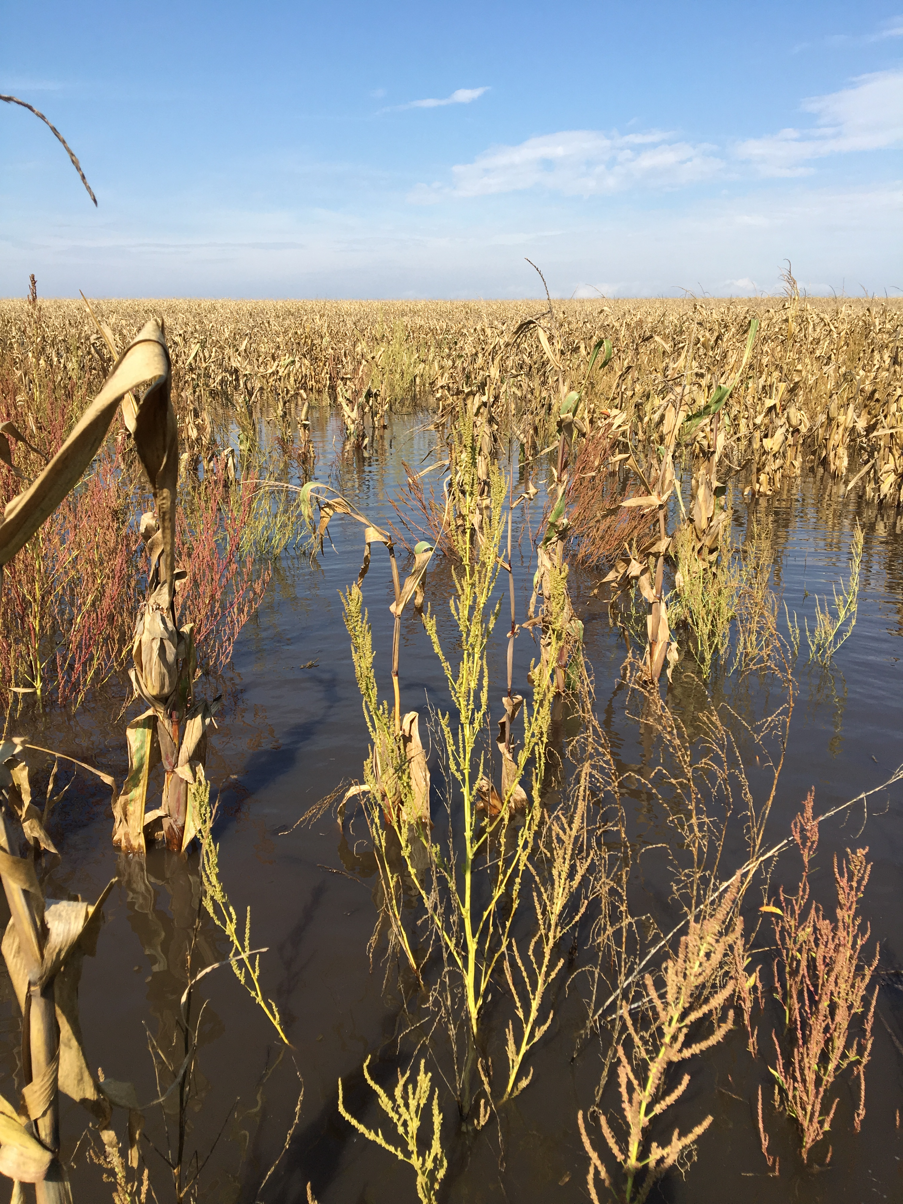 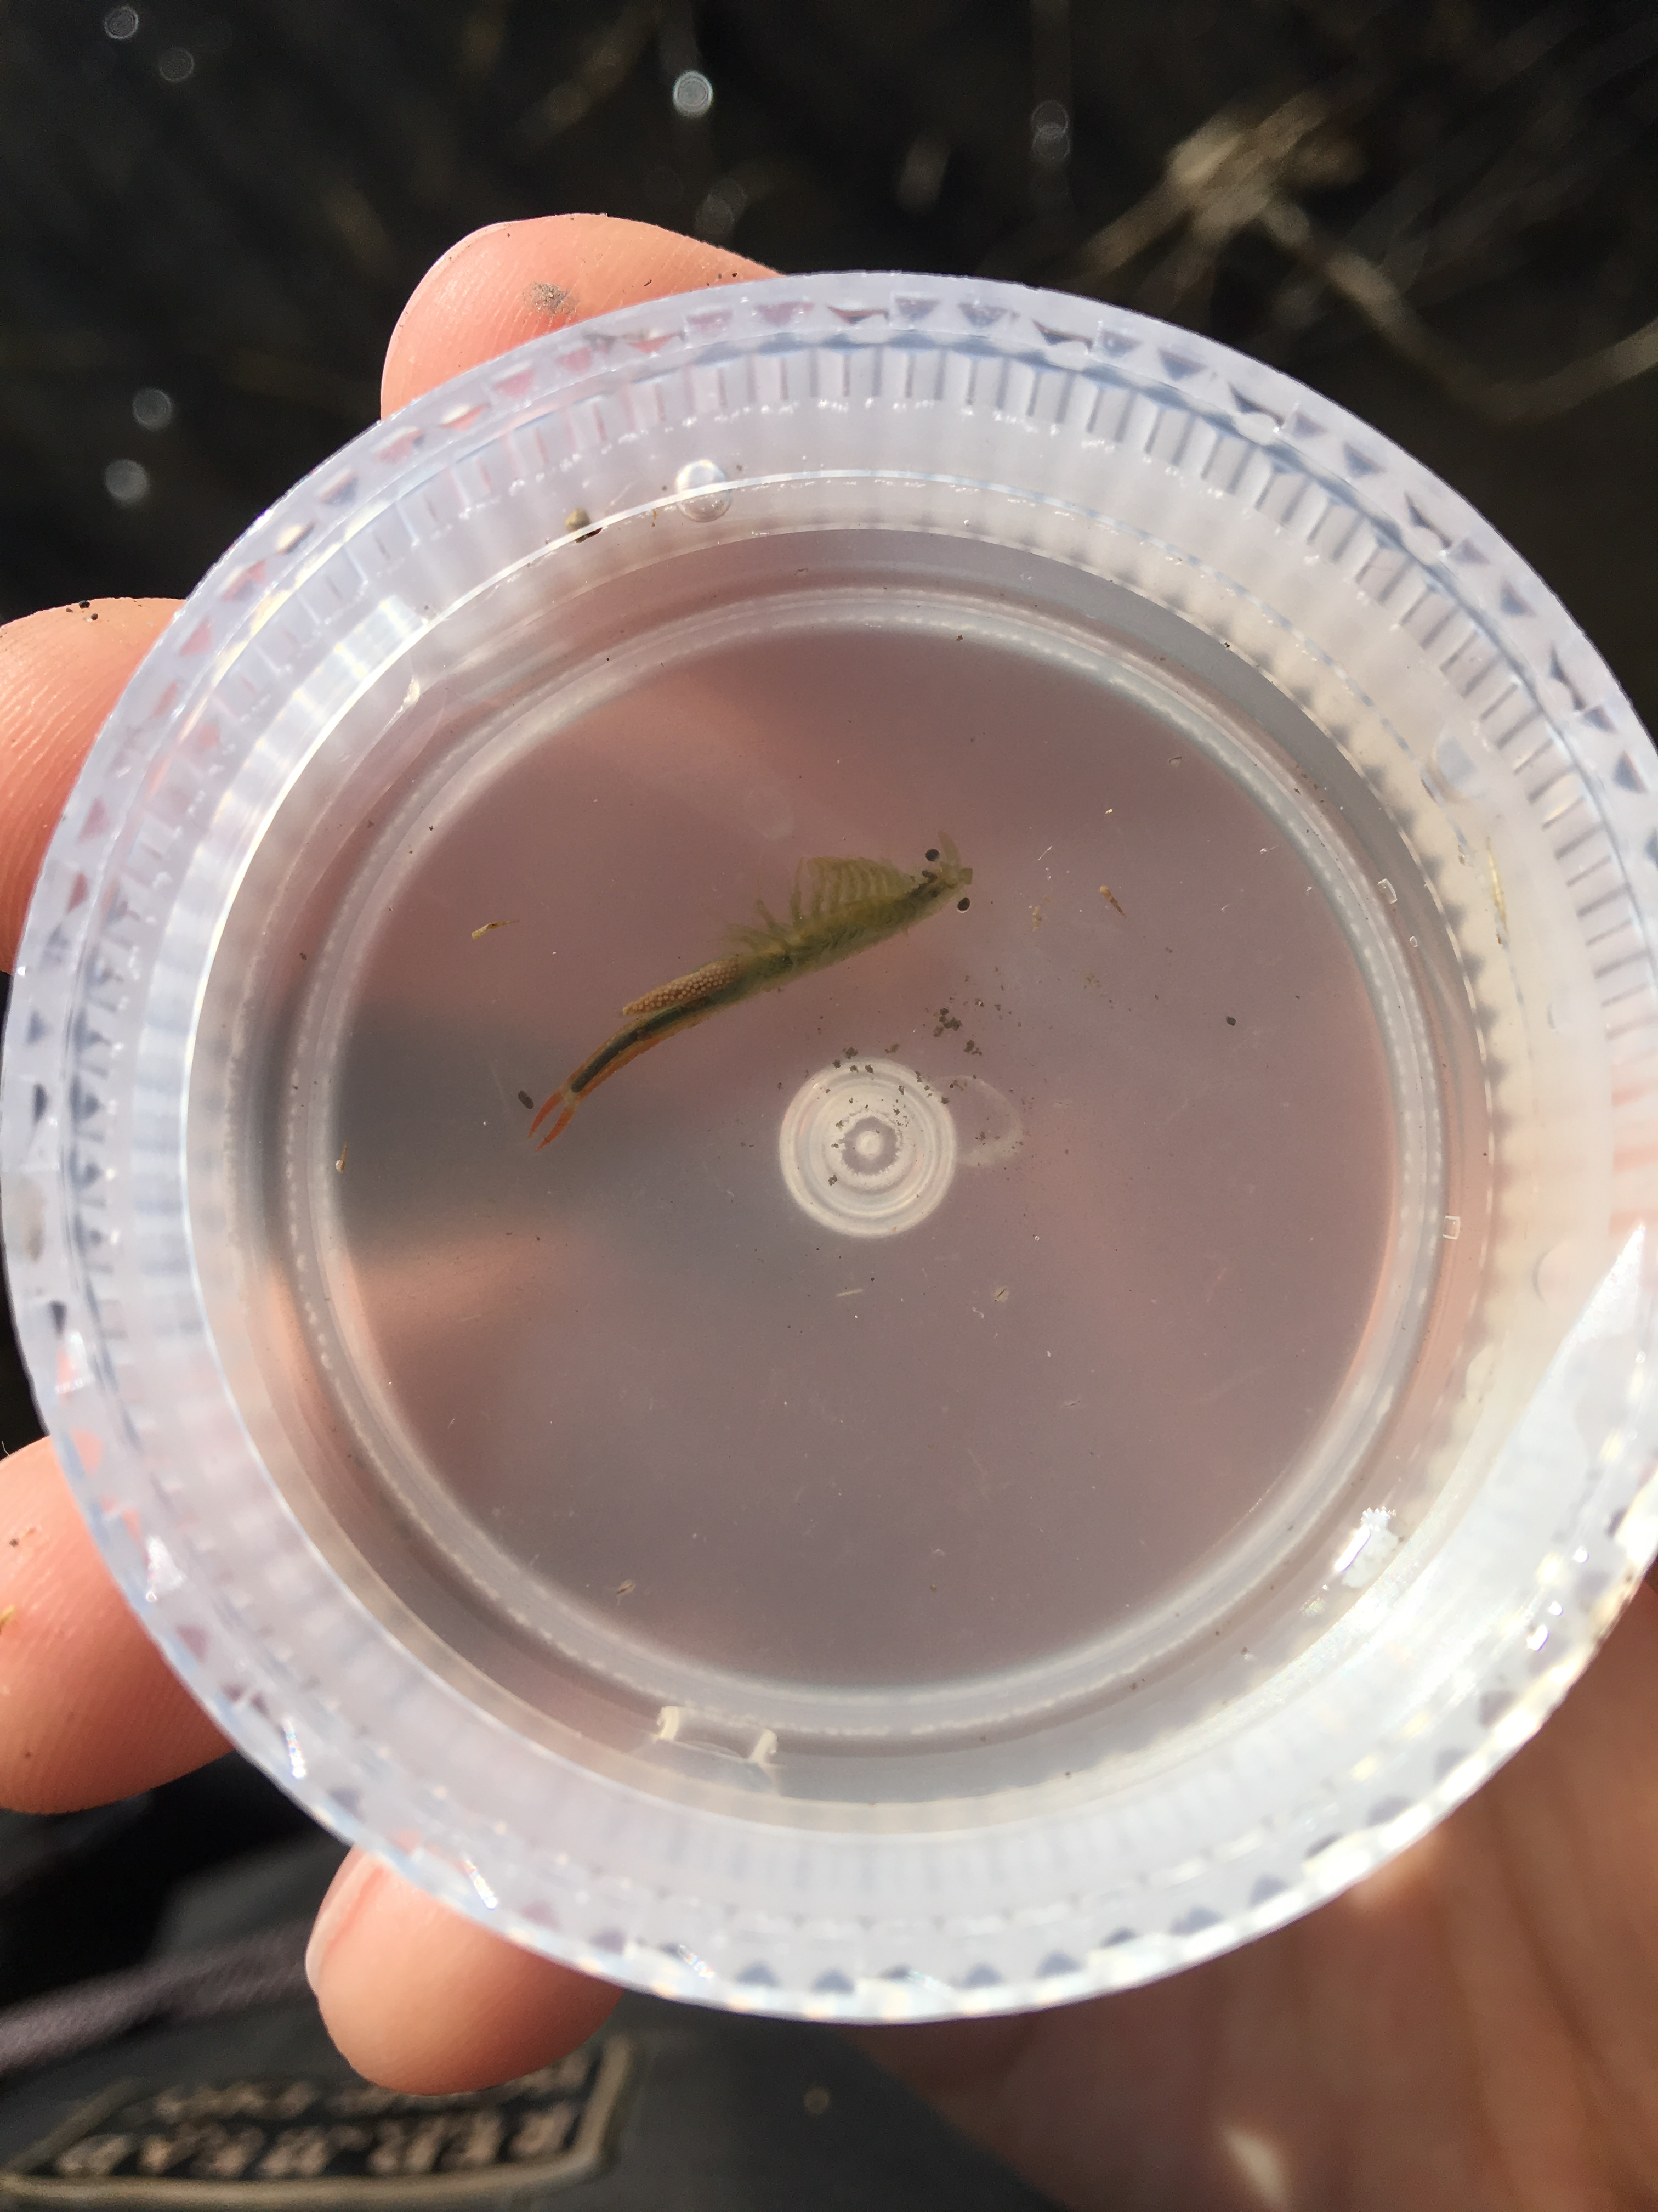

Figure 5. Left, ponding, shown from the center of the Lettuce pothole in late September. What plants exist growing in the main section of the pothole are primarily weeds, evidence of drown-out of the corn in this pothole. Right, a fairy shrimp scooped from the ponded water at Lettuce.

Objective 2: Modeling

Hydrologic modeling requires delineation of the drainage area (“microwatershed”) for each pothole. In this work, we have intentionally included monitoring of several potholes that are in series, such that some will, under very high flow events, spill over into others. This makes the watershed delineation somewhat complex, because under some rainfall conditions the watersheds of the series potholes are separate, and under other conditions they are merged. These nuances will be further explored as we refine our modeling capabilities in year 2. Figure 6 shows our current watershed delineations for the six conventional-field potholes.

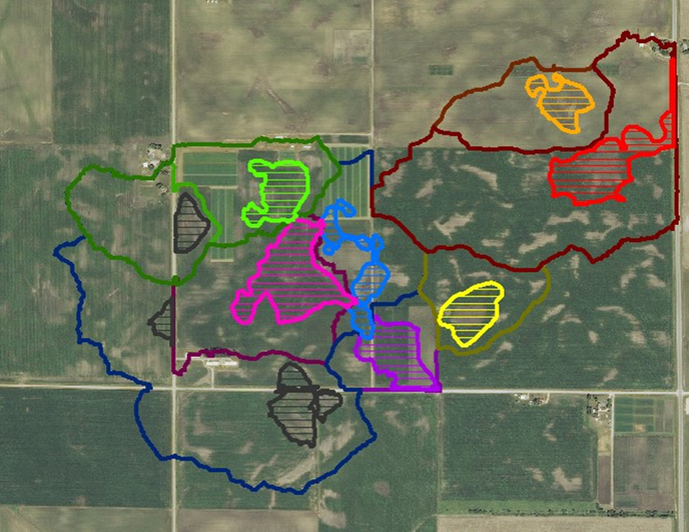

Figure 6. Microwatershed delineation for the six conventionally farmed potholes at Been and S. Woodruff. The CRP & Miscanthus pothole at Sorenson is not shown. Potholes are shown with hashed polygons, where the watershed delineations are open polygons. The brown potholes are ones that are not being monitored, and that would overflow into monitored potholes.

Building on preliminary work to use the AnnAGNPS model simulate observed ponded depth at two of the seven potholes (Bunny and Walnut), we have updated some of our parameterization through incorporating the observations of ponding from 2016. Figure 7 shows an example of the modeled and observed ponded depth for the Bunny pothole.

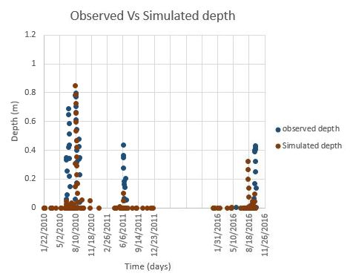

Figure 7. Observed and AnnAGNPS-simulated ponded depths for the Bunny pothole, for 2010, 2011, and 2016.

Model parameterization is in progress as well for Agro-IBIS. Figure 8 shows preliminary results for a historical period spanning 30 years. In Agro-IBIS we can allow the influence of ponded water to stress plants via the “drowning” function, which depends on ponding depth and duration. We will use the “drown off” option to calibrate the model to the bulk field (non-pothole) yields, and then use the “drown on” option to resolve the varying levels of stress throughout the pothole. The bottom panel of figure 8 indicates that, according to our current parameterization, historical ponding was not sever enough to cause damage to miscanthus. These results may change as we refine our parametrization.

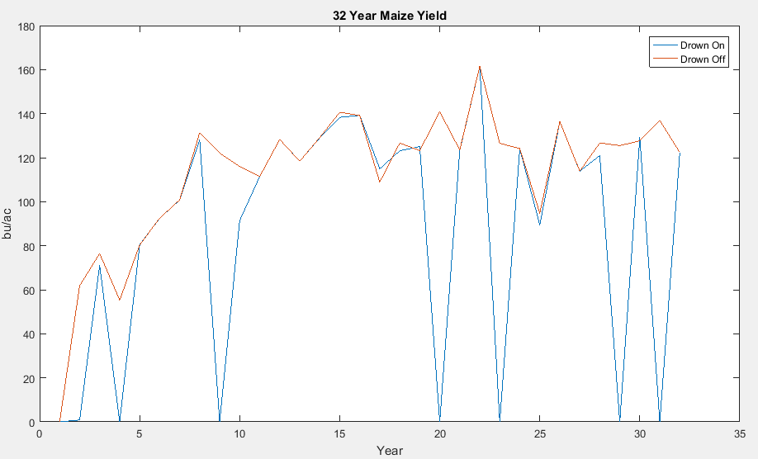

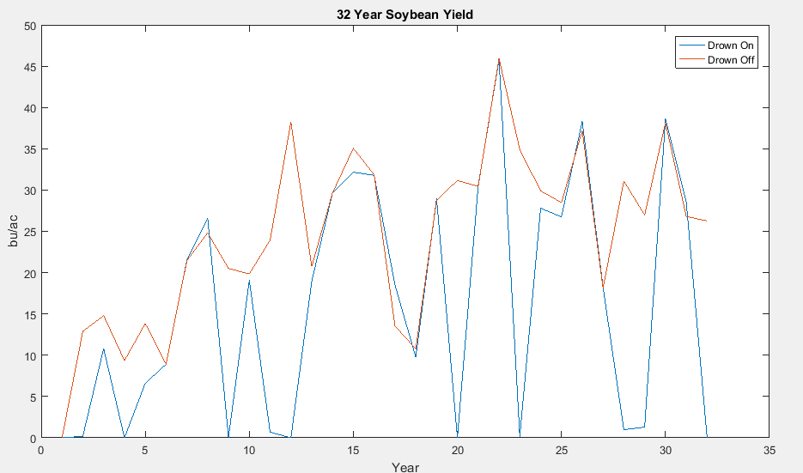

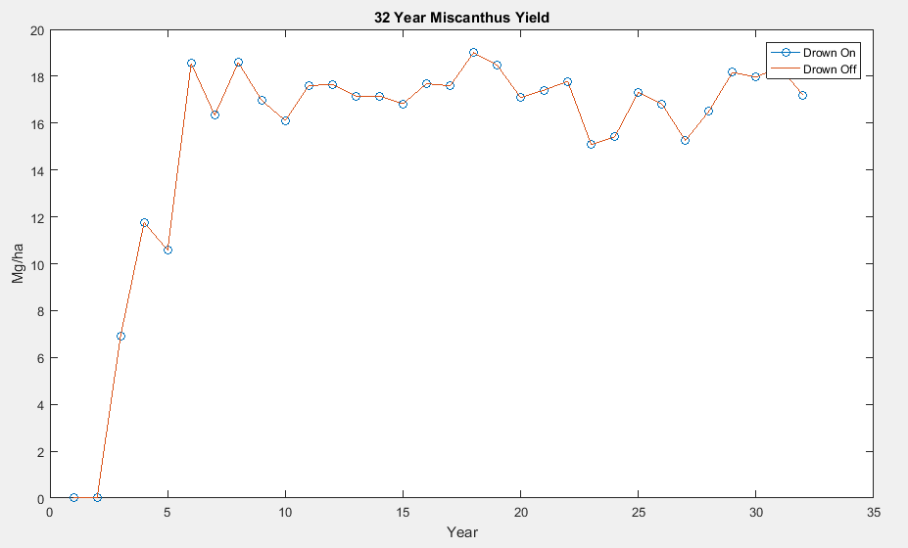

Figure 8. Preliminary Agro-IBIS calibration data for corn (top) soybean (middle) and miscanthus (bottom) with and without excess moisture stress (drown) using historical climate data.

## Year 1 Budget Report

We underspent in student support and tuition, because we budgeted a full year’s support for one engineering MS student, but the student did not start his program until May.

Although it appears that we underspent in lab analysis, it is because the Water Quality Lab that is analyzing our samples (a) is running behind and (b) bills quarterly. Accounting for these costs, we anticipate we will have overspent in this category for year 1, due to the very long duration of ponded conditions at several of the potholes; we had budgeted for 48 water quality samples and collected 77 at Lettuce and Mouth that will be charged to this project (an additional 22 will be charged to a related project).

## Year 2 Budget Request

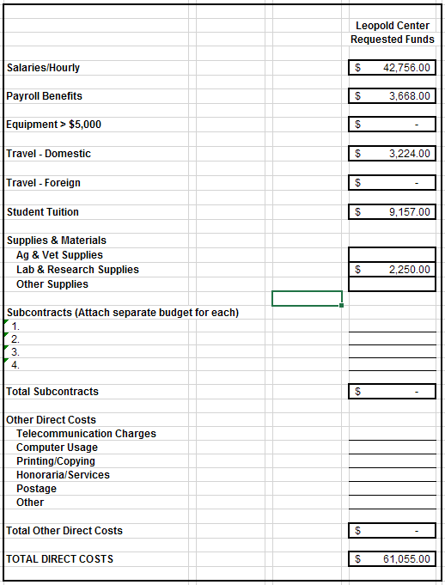

**Salaries/Hourly:** We are requesting salary for one engineering MS student at a starting rate $2,060 per month for 12 months, and support for one non-engineering MS student at a starting rate of $2,060 per month for 6 months (or half support for 12 months). The non-engineering MS student is partially funded through other related means. We are also requesting 2 undergraduate hourly students to assist with monitoring and field work during the summer, at a starting rate of $946 per month for three months each. Salaries represent a standard 3% increase over year 1.

**Payroll Benefits:** The benefits rate for graduate students is 9.8%; for undergraduate students it is 0.6%. We thus include $3634 in benefits for the two graduate students, and $34 for the two undergraduate students.

**Equipment:** None.

**Travel:** We have budgeted $596 to cover travel expenses associated with visits to the field sites (car rental or mileage) for the students, as well as outreach events by various team members. We add an additional $2628 to fund graduate student travel to present our work at a professional scientific meeting (two, at approximately $410 for meeting registration, $505 for airfare/mileage, lodging at $91/night plus meals at $42/day for 3 day meeting).

**Student Assistance/Tuition/Support:** 50% of the tuition for an engineering MS student is included for spring, summer, and fall terms ($6,387). 25% of the tuition for a non-engineering MS student is included for spring, summer, and fall terms ($2,770).

**Supplies/Materials:** We have assumed 75 water quality samples per year at $30 each.

**Subcontracts:** None.

**Other Direct Costs:** None.